This is how my **Home** page look. There are picture links to other pages of website and little biography.

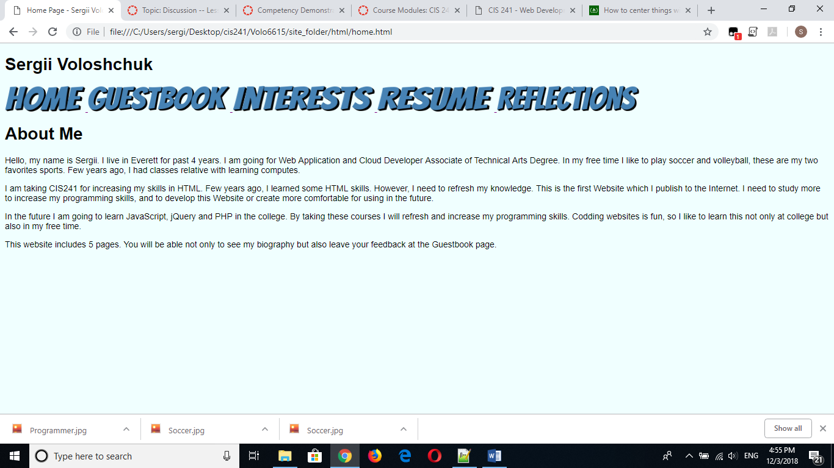

On my **Guestbook** page there some forms for gathering information from user

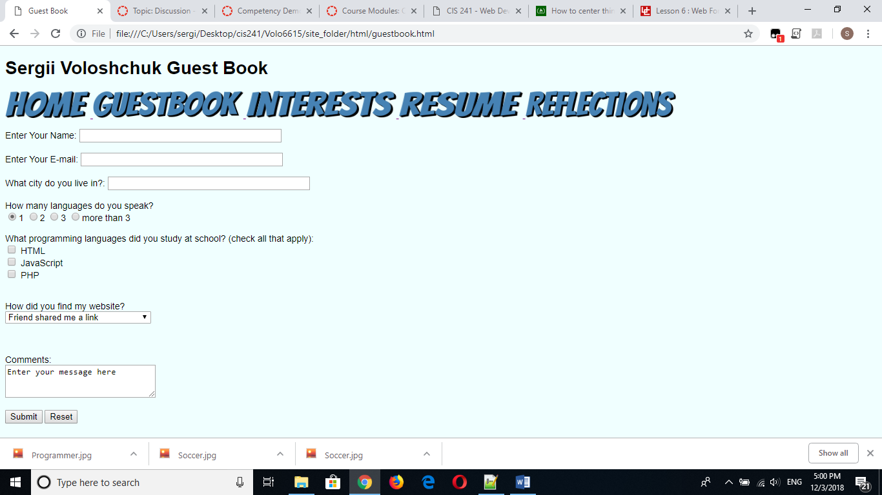

In the **Interests page**  I have inserted some links which guide user to different websites, and this links open in new browser instance. Also there are pictures which describe my interests

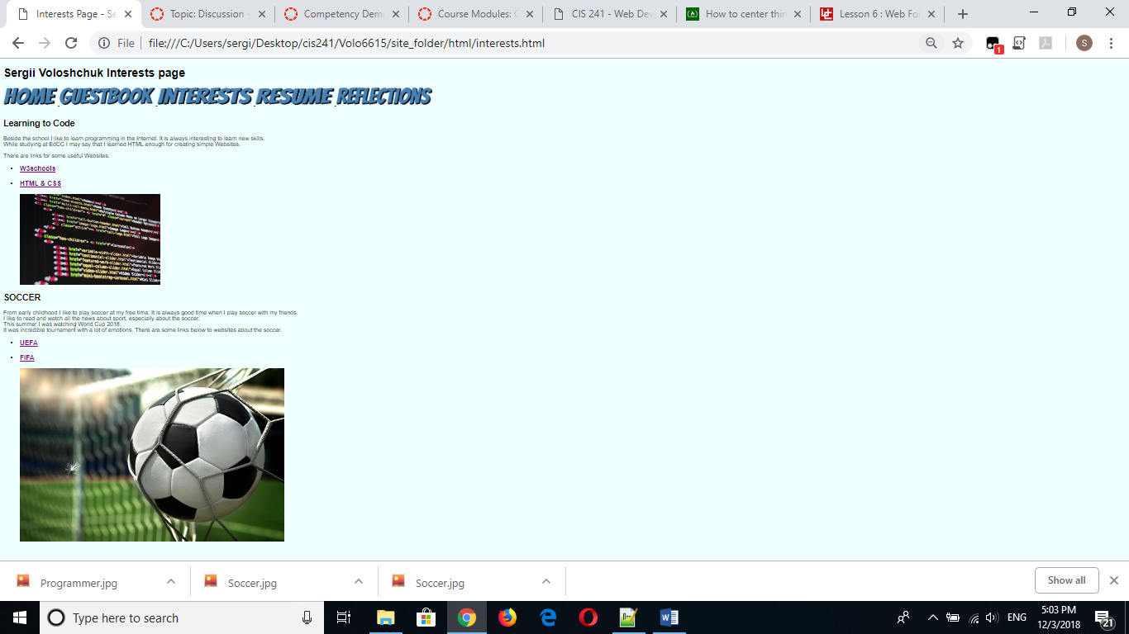

I created **Resume**  page by tables. As I just started learning programming there is only information about my education so far.

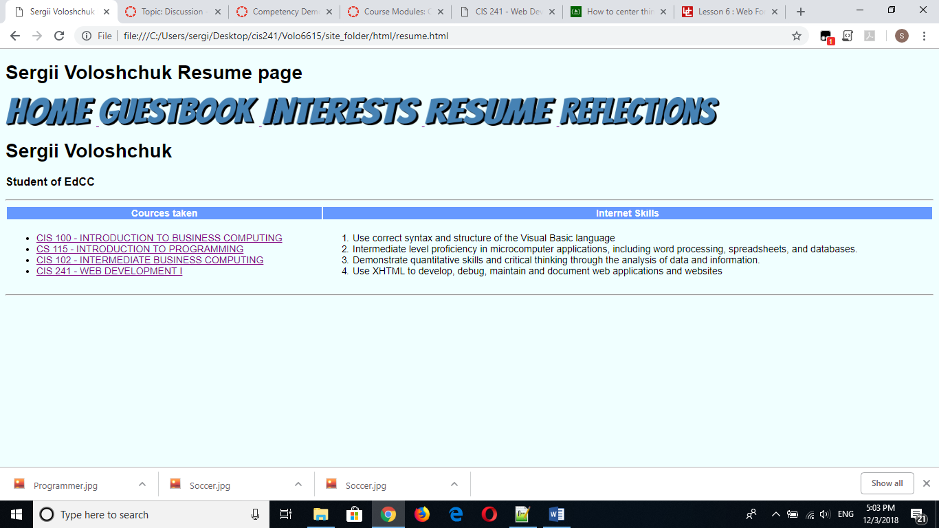

There is my **Reflections**  page

